**Google Map Implementation in Xamarin.Forms**

Contents

1. Overview........................................................................................................................
2. Steps to Implement Google Map....................................................................................

a. Install Xamarin.Forms.GoogleMaps from Nuget.....................................................

b. Maps Initializationfor respective platforms.........................................................

c. Give the Required Permissions for the respective platforms..............................

d. Consume the map into your application..............................................................

3. Generating Google Maps API Key for the Respective Platforms.....................................

3.1 Obtaining a Maps API v2 key for android........................................................................

4. Map application demo .....................................................................................................

4.1 Map with instant prompts.................................................................................................

4.2 Path route between two location..........................................................................…........

4.3 Nearby places search......................................................................................................

4.3.1 Show path from current position to searched results.

4.3.2 Configure the button text from settings page

4.4 Configuration of Map attributes.......................................................................................

1) Overview

To Implement Google Map Xamarin.Forms uses the native map APIs on each platform i.e. some configuration steps are needed to adhere to each platforms specific API requirements.

2) Following are the steps:

a) Install Xamarin.Forms.GoogleMaps from **Nuget**

**Or (** Install-Package Xamarin.Forms.GoogleMaps -Version 2.2.1 **)**

b) Maps Initializationfor respective platforms

For iOS: Xamarin.FormsGoogleMaps.Init( Google Map API KEY );

For Android :Xamarin.FormsGoogleMaps.Init(this, bundle); (For Android either you can add Google Map API KEY in

Android Manifest file or you can add in Attribute in a class which inherits Application class)

<meta-data android:name="com.google.android.maps.v2.API_KEY" android:value="AbCdEfGhIjKlMnOpQrStUvWValueGoesHere" />

Or 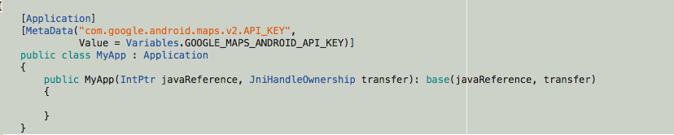

c) Give the Required Permissions for the respective platforms

For ioS: <key>NSLocationAlwaysUsageDescription</key>

<string>Can we use your location </string>

<key>NSLocationWhenInUseUsageDescription</key>

<string>We are using your location</string>

For Android: AccessCoarseLocation

AccessFineLocation

AccessLocationExtraCommands

AccessMockLocation

AccessNetworkState

AccessWifiState

Internet

d) Consume the map into your application

var map = new Map( MapSpan.FromCenterAndRadius

( new Position(37,-122), Distance.FromMiles(0.3)))

{

IsShowingUser = true,

HeightRequest = 100,

WidthRequest = 960,

VerticalOptions = LayoutOptions.FillAndExpand

};

var stack = new StackLayout { Spacing = 0 };

stack.Children.Add(map);

Content = stack;

3)  **Generating Google Maps API Key for the Respective Platforms**

3.1) **For Android:** Obtaining a Maps API v2 key involves the following steps:

1. Retrieve the SHA-1 fingerprint of the keystore that is used to sign the application.
2. Create a project in the Google APIs console.
3. Obtaining the API key.

For more detail follow below link:

**==>** <https://developer.xamarin.com/guides/android/platform_features/maps_and_location/maps/obtaining_a_google_maps_api_key/>

4) Map application demo

4.1) Map with instant prompts

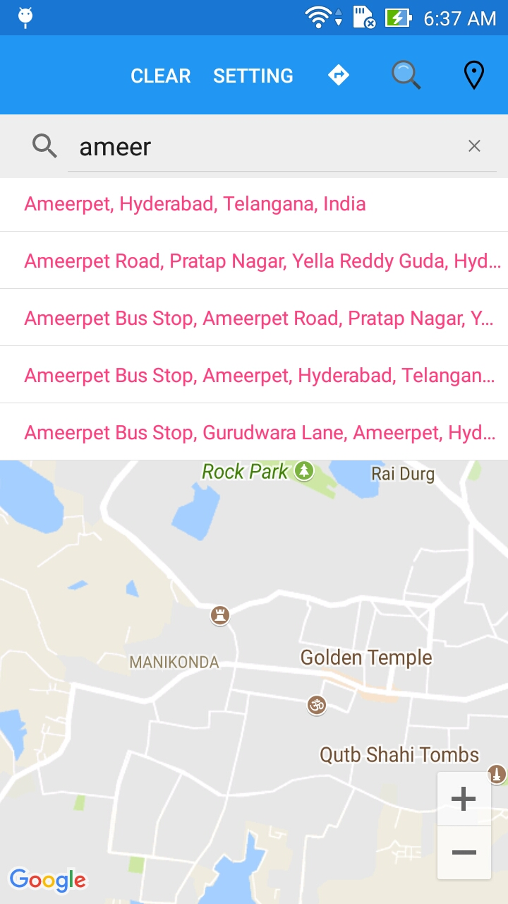 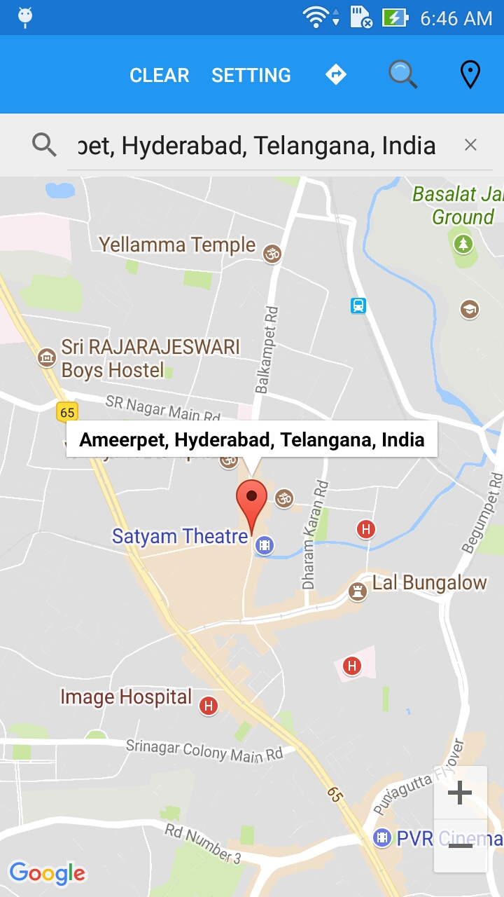

This instant prompts feature gives you the predictions based on your keyword . As you can see in above screenshots ,I typed ameer and it gives me the instant prompts based on my keywords.

Also when we will select the address ,it locates the address with help of pin with location details.

4.2) Path route between two location

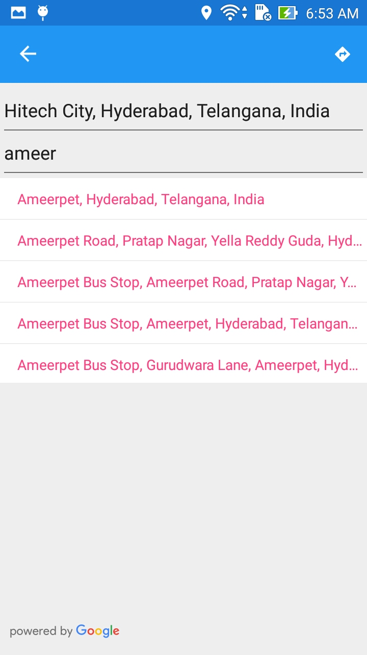 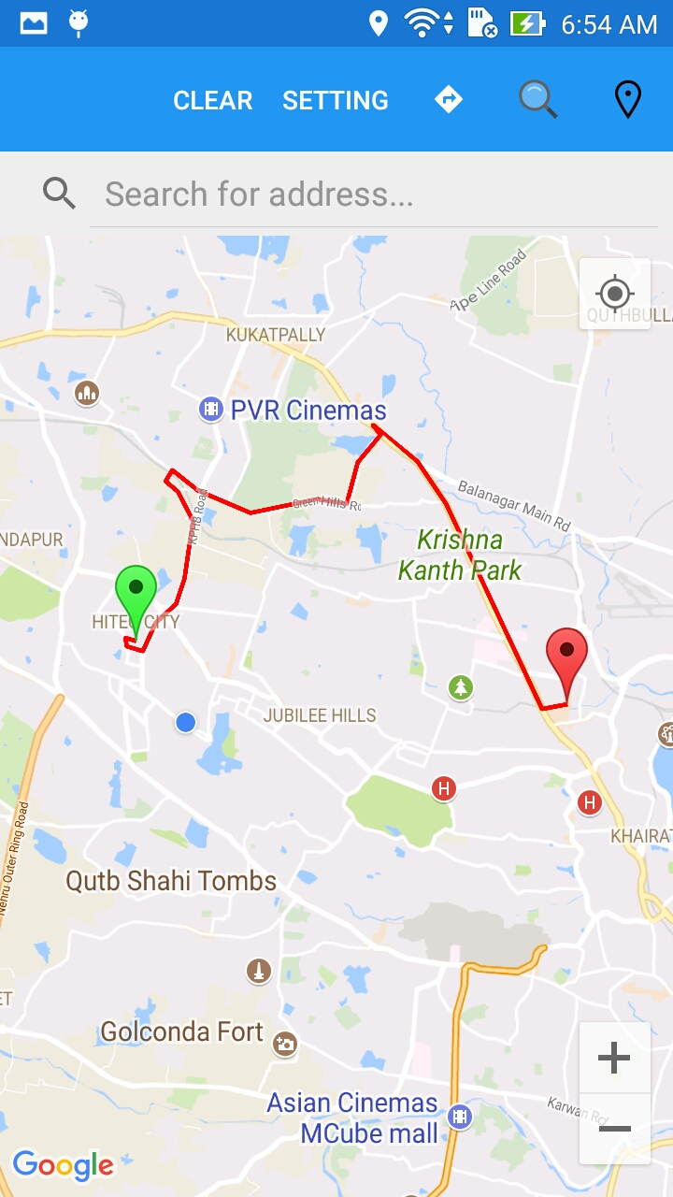

This allows us to find the driving route between two location. For this we have to enter the **FROM** position and **TO** position and then click get route button. It draws a route on the map as shown in above screenshots. The green pin denotes the starting position and red pin denotes the end position and the red polyline is the actual driving route.

4.3) Nearby places search

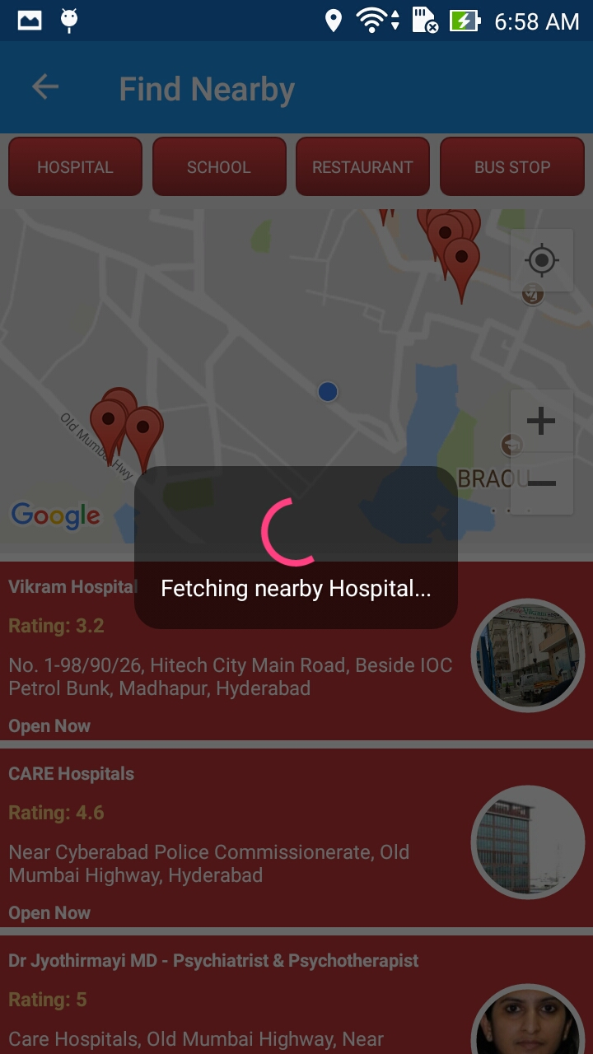 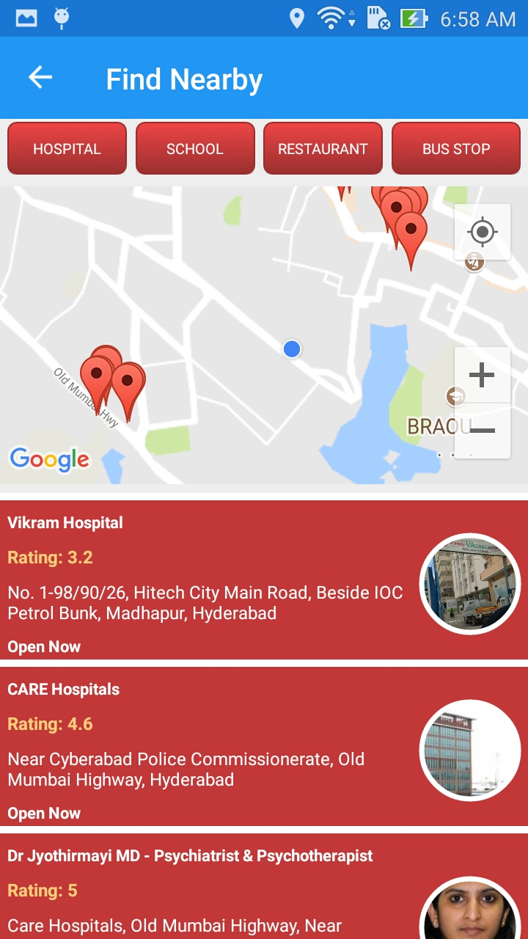

This allows you to search nearby places like hospitals, schools etc . You need to click the respective button to get the results .These buttons are configurable and one can configure from settings page.

Her we are showing place name, rating ,address , status and respective images as you can see in above screenshots.

For this we have used google maps nearby API.

4.3.1) Show path from current position to searched results

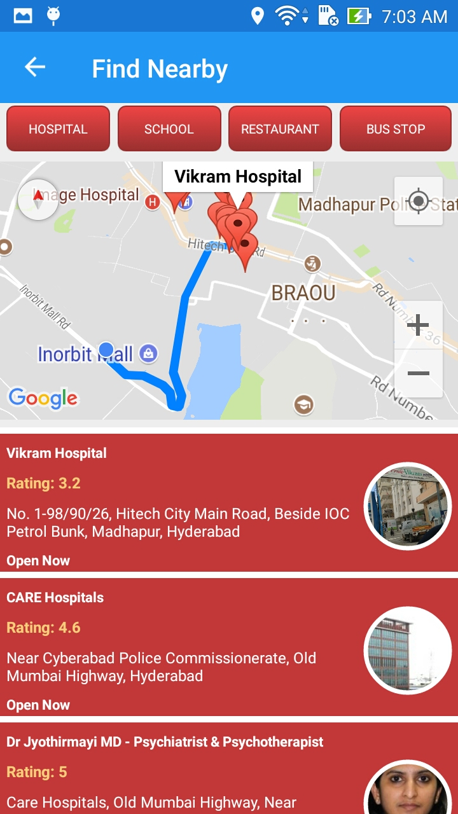 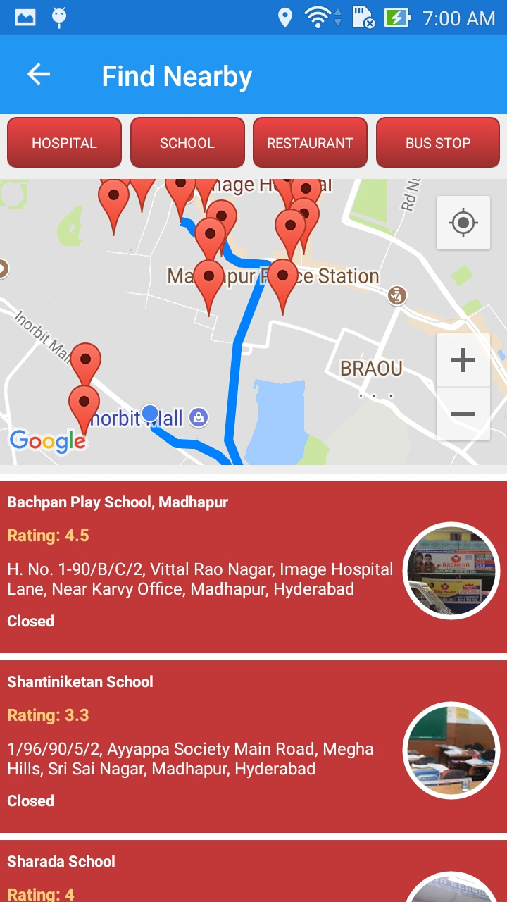

One can also get the route from current location to nearby search results. You need to tap the list item for this. You can see in above screenshots ,blue dot is showing current position and from there path is drawn to the respective tapped place in the list.

4.3.2) Configure the button text from settings page

As I told you that the buttons text here (**in Find Nearby page**) are configurable. You can change the button text as per your need from the settings page. See below screenshots.

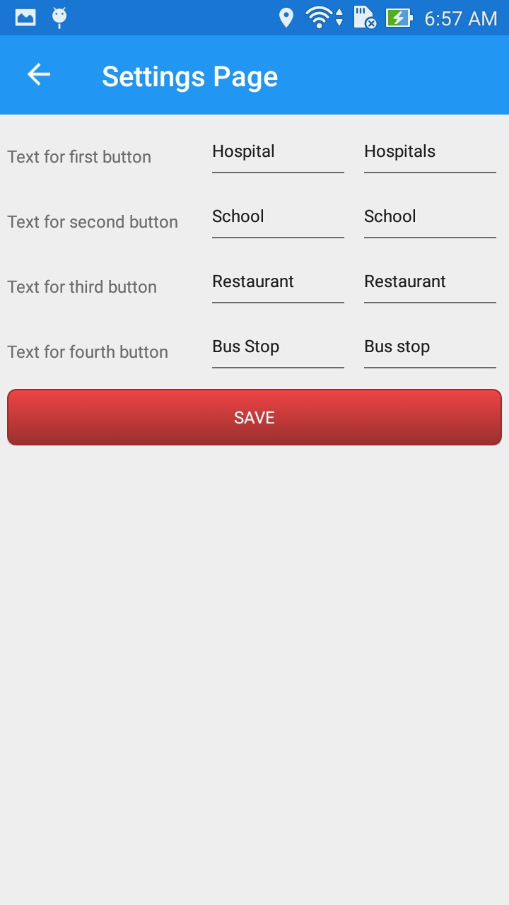 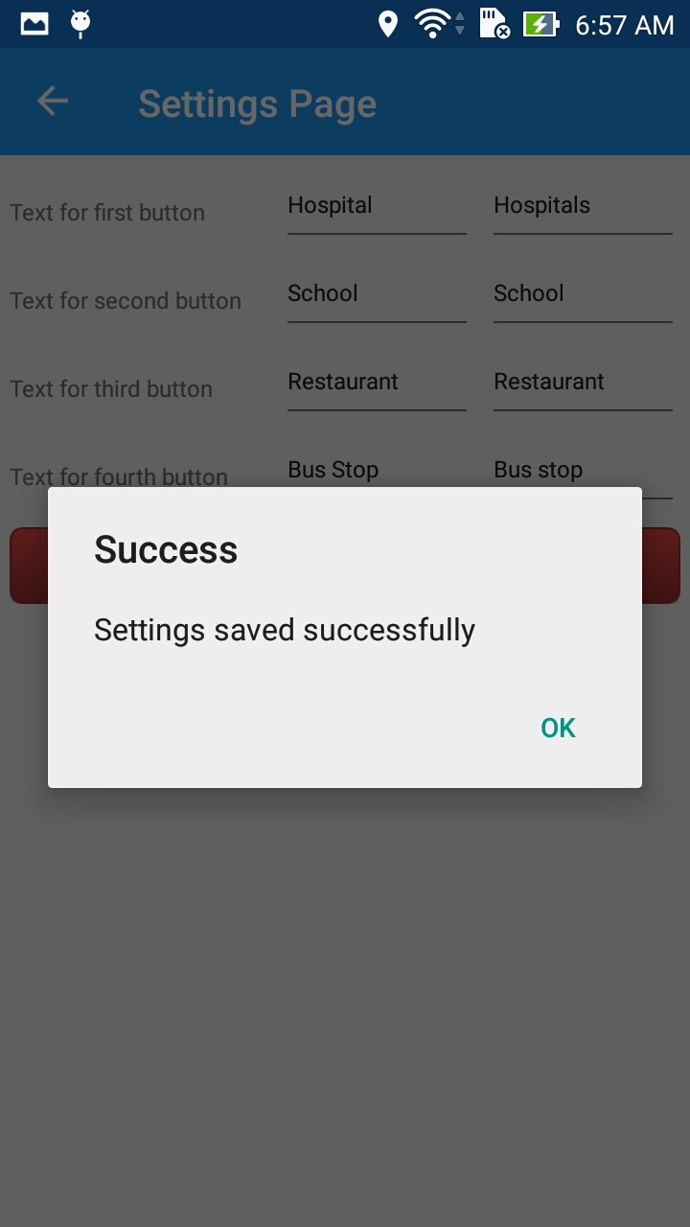

Above screenshots are of settings page .Here you can set the text for the buttons and search keywords for the respective button.

4.4) Configuration of Map attributes

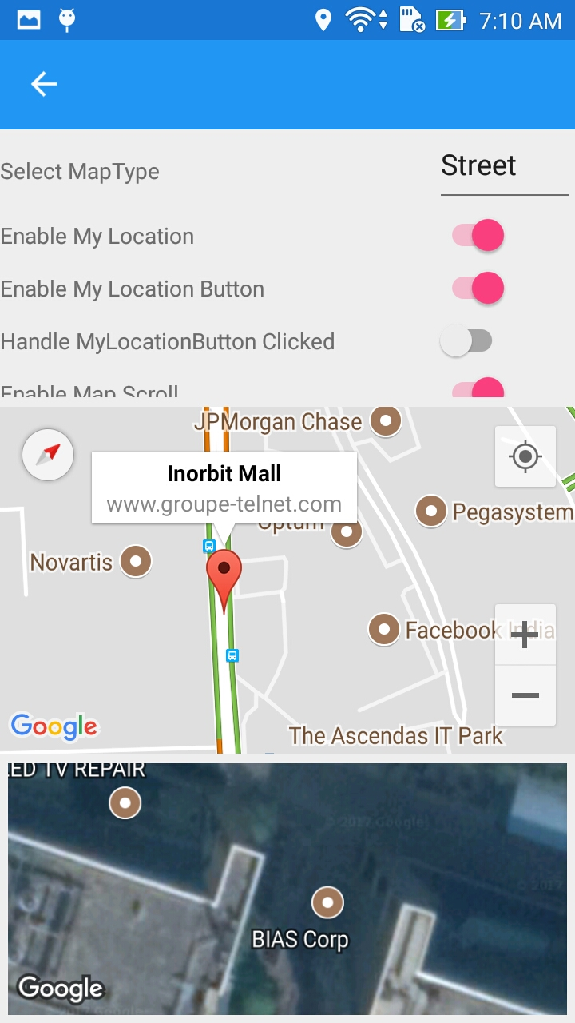 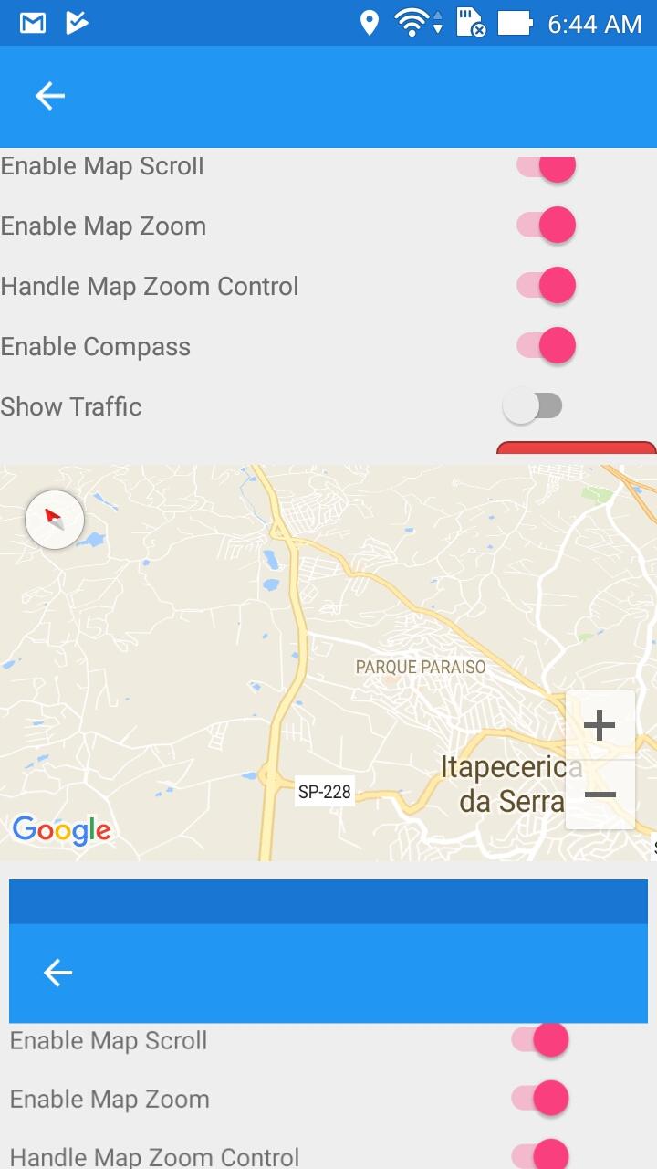

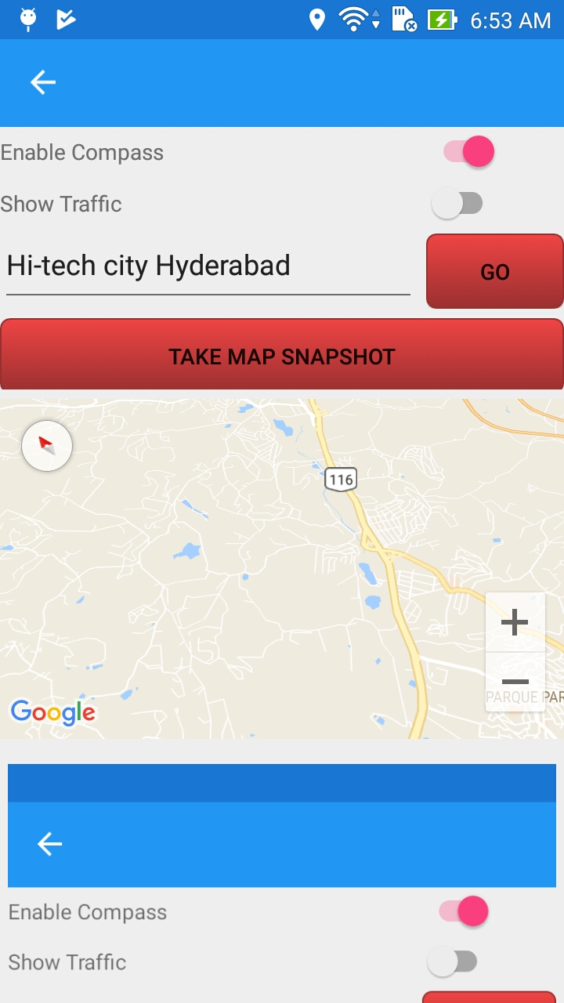

Here